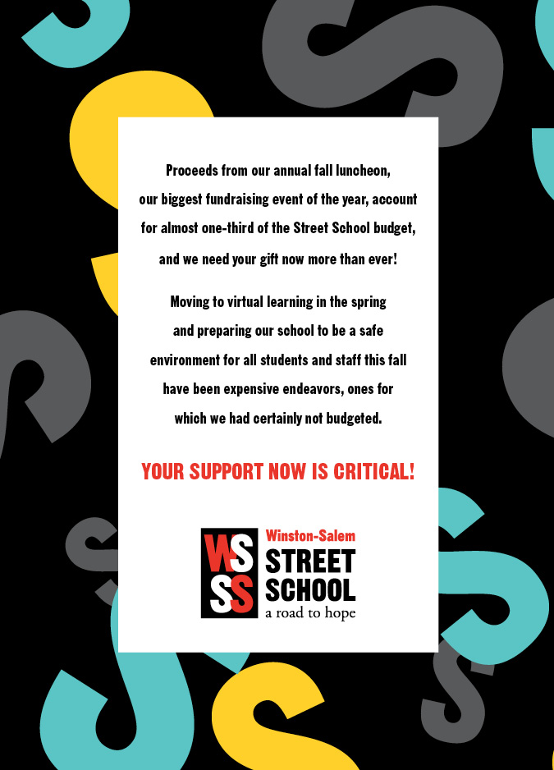

We hope you will make plans to join us on October 6th, at noon. If you are unable, you can also make a safe, online contribution to show your support of this important fundraising event.

Visit: [www.wsstreetschool.org/donate](http://www.wsstreetschool.org/donate)

Thank you for supporting the

